

**Lab Manual- Utilize prompt engineering in your application (Part 2)**

**Prepared for**:

**Date:** 18th Dec 2023

**Prepared by:**

Document Name: Lab Manual **Document Number** AZLabn917

**Contributor:**

Contents

1. Objective 3

2. Provision an Azure Open AI Services resource 4

3. Deploy a model 7

4. Use the Chat playground 11

5. Experiment Prompt (Explore prompt engineering techniques) 15

6. Prepare to develop an app in Visual Studio Code 23

7. Configure your application 23

8. Add code to use the Azure OpenAI service 24

9. Run your application 25

# Objective

Azure OpenAI Service brings the generative AI models developed by OpenAI to the Azure platform, enabling you to develop powerful AI solutions that benefit from the security, scalability, and integration of services provided by the Azure cloud platform. In this exercise, you'll learn how to get started with Azure OpenAI by provisioning the service as an Azure resource and using Azure OpenAI Studio to deploy and explore generative AI models.

In the scenario for this exercise, you will perform the role of a software developer who has been tasked to implement an AI agent that can use generative AI to help a marketing organization improve its effectiveness at reaching customers and advertising new products. The techniques used in the exercise can be applied to any scenario where an organization wants to use generative AI models to help employees be more effective and productive.

This exercise takes approximately **30** minutes.

.

# Provision an Azure Open AI Services resource

1. Sign into the **Azure portal** at <https://portal.azure.com>.
2. Search Azure Open Ai

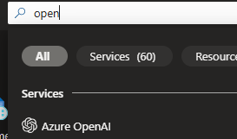

1. Create an **Azure OpenAI** resource with the following settings:
   * **Subscription**: Select an Azure subscription that has been approved for access to the Azure OpenAI service
   * **Resource group**: Choose or create a resource group
   * **Region**: Make a ***random*** choice from any of the following regions*
     + Australia East
     + Canada East
     + East US
     + East US 2
     + France Central
     + Japan East
     + North Central US
     + Sweden Central
     + Switzerland North
     + UK South
   * **Name**: A unique name of your choice
   * **Pricing tier**: Standard S0

* Azure OpenAI resources are constrained by regional quotas. The listed regions include default quota for the model type(s) used in this exercise. Randomly choosing a region reduces the risk of a single region reaching its quota limit in scenarios where you are sharing a subscription with other users. In the event of a quota limit being reached later in the exercise, there's a possibility you may need to create another resource in a different region.

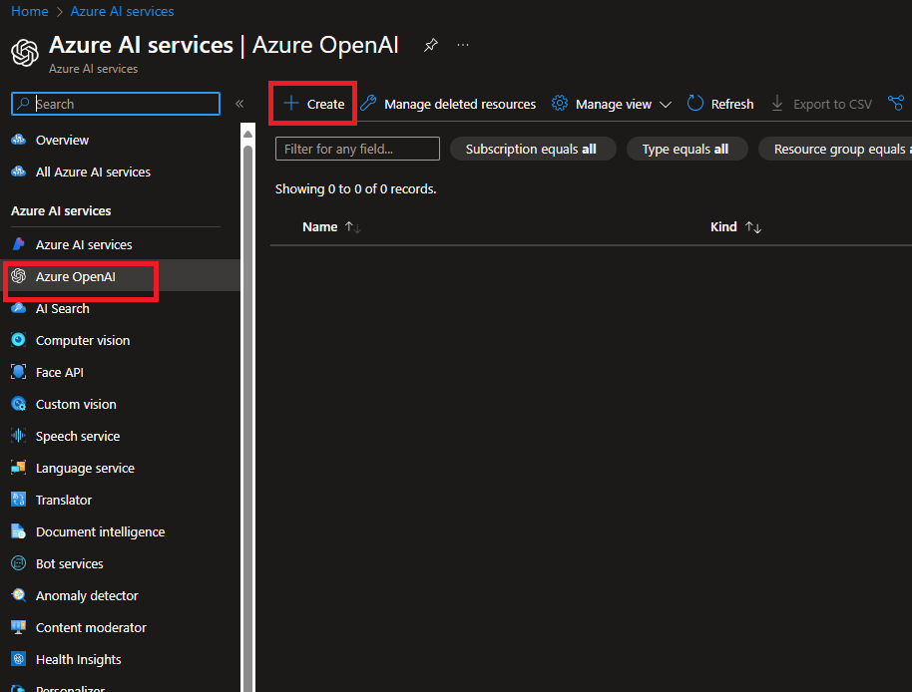

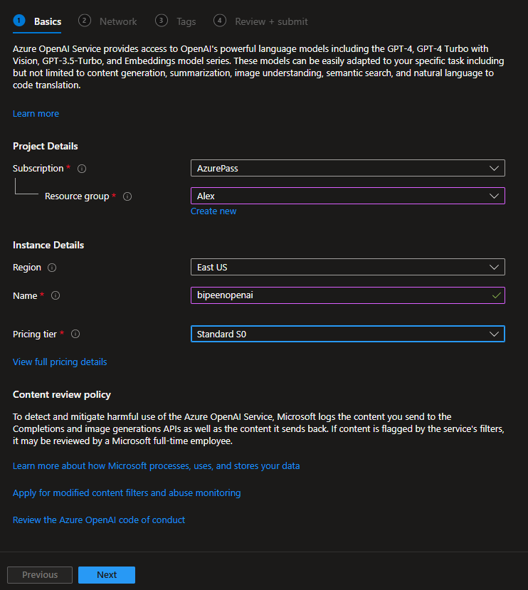

1. Wait for deployment to complete. Then go to the deployed Azure OpenAI resource in the Azure portal.

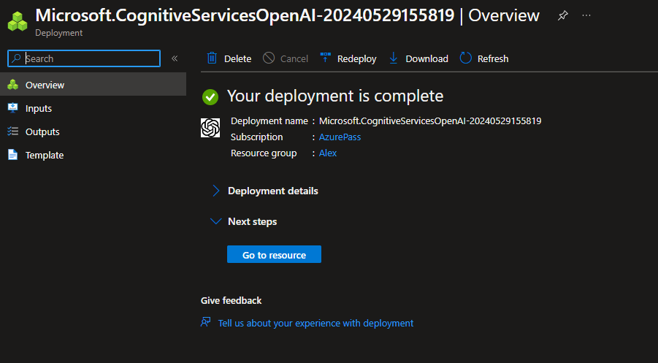

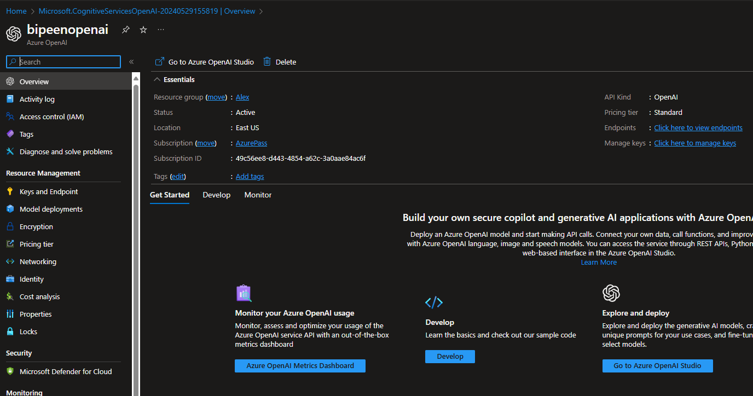

# Deploy a model

Azure OpenAI service provides a web-based portal named **Azure OpenAI Studio**, that you can use to deploy, manage, and explore models. You'll start your exploration of Azure OpenAI by using Azure OpenAI Studio to deploy a model.

**Note**: As you use Azure OpenAI Studio, message boxes suggesting tasks for you to perform may be displayed. You can close these and follow the steps in this exercise.

1. In the Azure portal, on the **Overview** page for your Azure OpenAI resource, use the **Go to Azure OpenAI Studio** button to open Azure OpenAI Studio in a new browser tab.

After the new tab opens, you can close any banner notifications for new preview services that are displayed at the top of the Azure OpenAI Studio page.

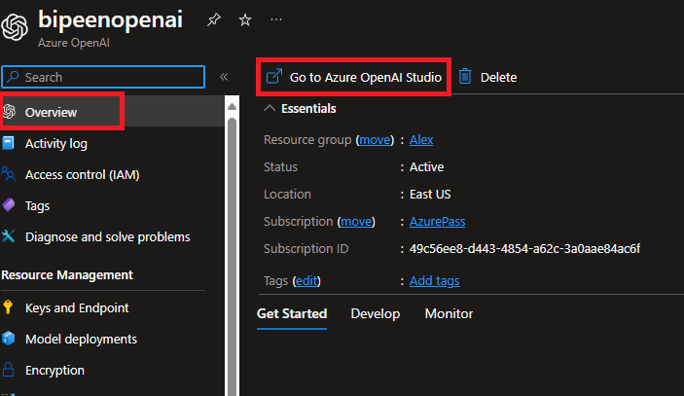

1. Create a new **deployment** of the **gpt-35-turbo-16k** model with the following settings:
   * **Model**: gpt-35-turbo-16k (if the 16k model isn't available, choose gpt-35-turbo)
   * **Model version**: Auto-update to default
   * **Deployment name**: A unique name of your choice
   * **Advanced options**
     + **Content filter**: Default
     + **Deployment type**: Standard
     + **Tokens per minute rate limit**: 5K*
     + **Enable dynamic quota**: Enabled

* A rate limit of 5,000 tokens per minute is more than adequate to complete this exercise while leaving capacity for other people using the same subscription.

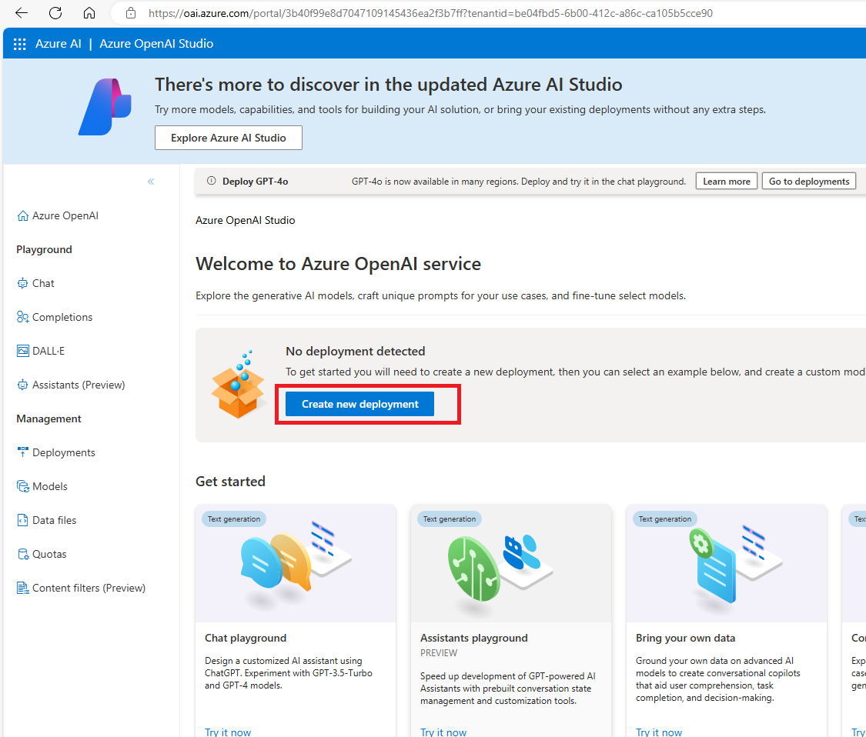

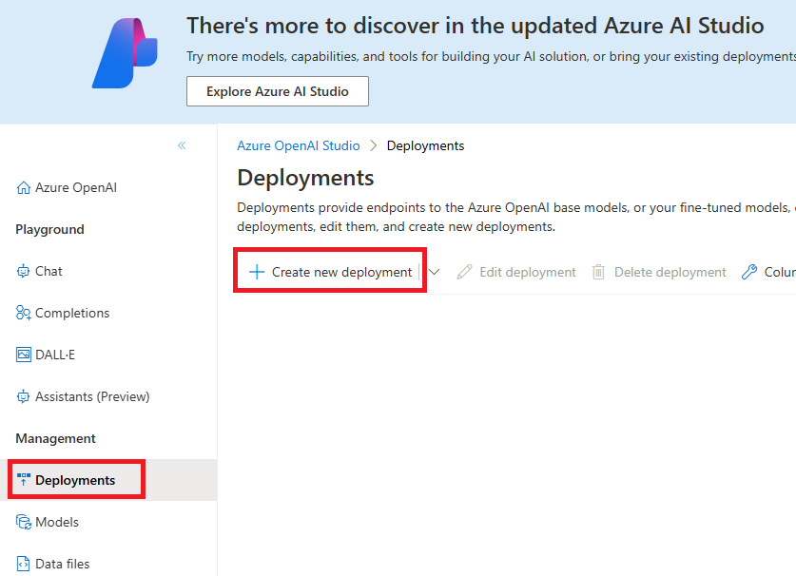

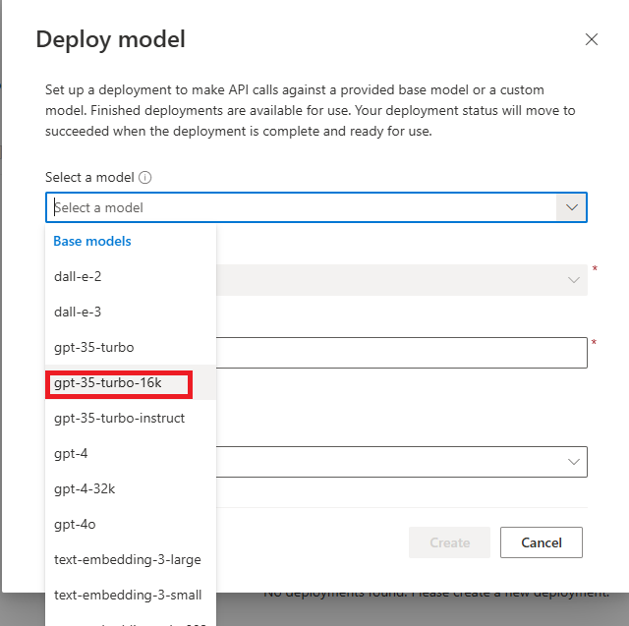

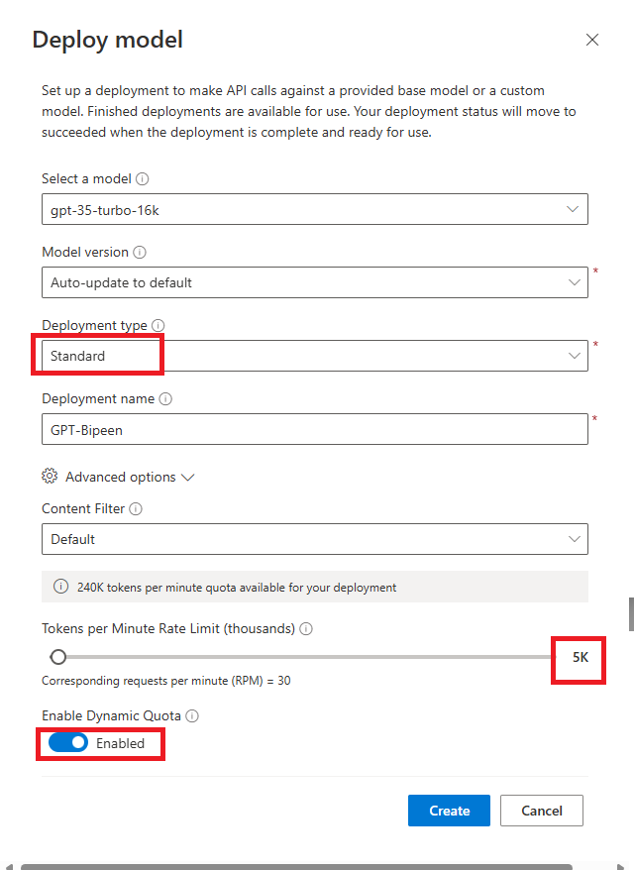

You Should receive the success message

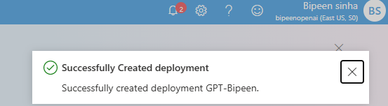

# Use the Chat playground

Now that you've deployed a model, you can use it to generate responses based on natural language prompts. The Chat playground in Azure OpenAI Studio provides a chatbot interface for GPT 3.5 and higher models.

**Note:** The Chat playground uses the ChatCompletions API rather than the older Completions API that is used by the Completions playground. The Completions playground is provided for compatibility with older models.

1. In the **Playground** section, select the **Chat** page. The **Chat** playground page consists of three main panels (which may be arranged right-to-left horizontally, or top-to-bottom vertically depending on your screen resolution):
   * **Setup** - used to set the context for the model's responses.
   * **Chat session** - used to submit chat messages and view responses.
   * **Configuration** - used to configure settings for the model deployment.

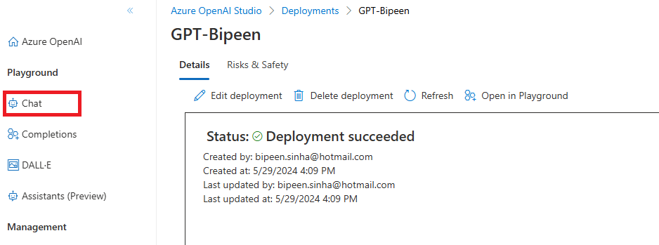

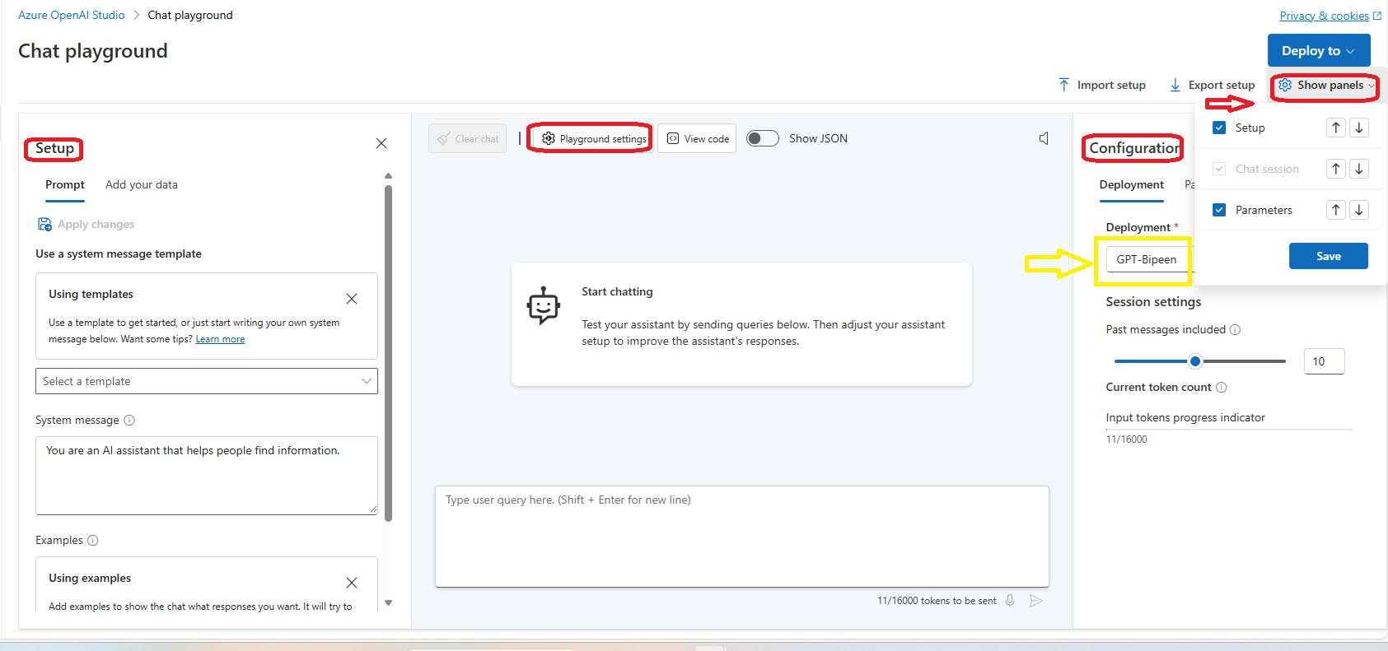

1. In the **Configuration** panel, ensure that your gpt-35-turbo-16k model deployment is selected.

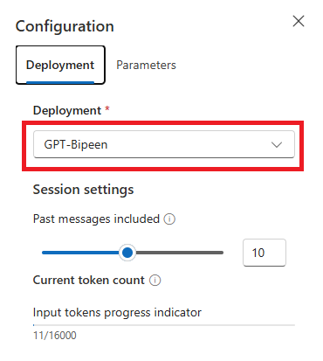

1. In the **Setup** panel, review the default **System message**, which should be You are an AI assistant that helps people find information. The system message is included in prompts submitted to the model, and provides context for the model's responses; setting expectations about how an AI agent based on the model should interact with the user.

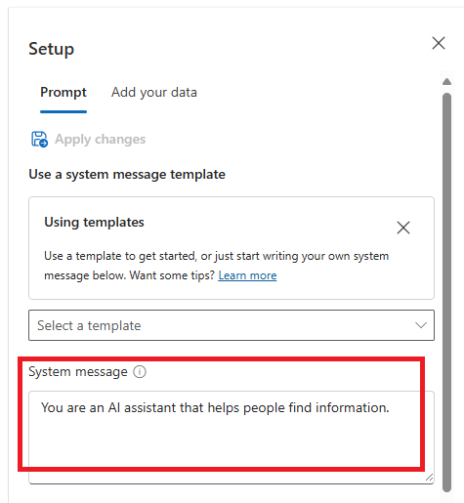

1. In the **Chat session** panel, enter the user query How can I use generative AI to help me market a new product?

**Note**: You may receive a response that the API deployment is not yet ready. If so, wait for a few minutes and try again.

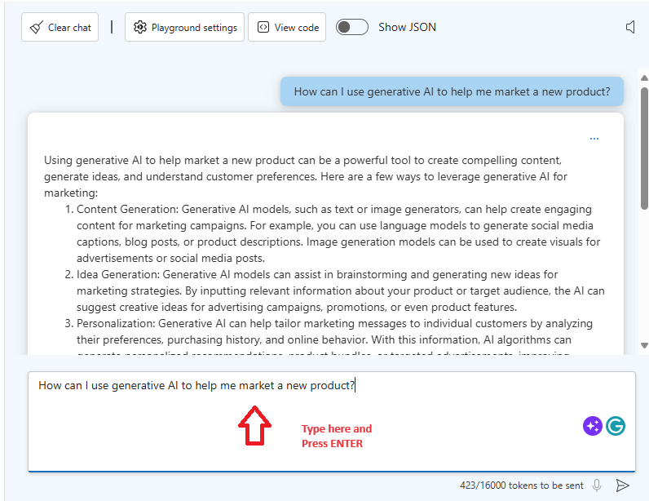

1. Review the response, noting that the model has generated a cohesive natural language answer that is relevant to the query with which it was prompted.
2. Enter the user query What skills do I need if I want to develop a solution to accomplish this?.

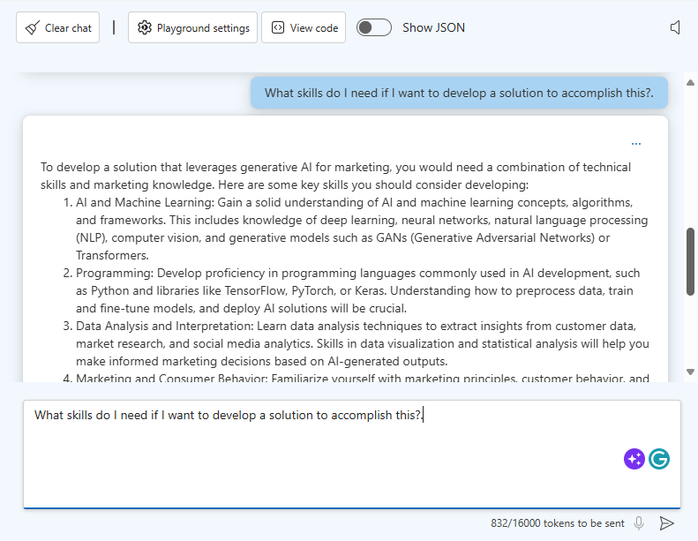

1. Review the response, noting that the chat session has retained the conversational context (so "this" is interpreted as a generative AI solution for marketing). This contextualization is achieved by including the recent conversation history in each successive prompt submission, so the prompt sent to the model for the second query included the original query and response as well as the new user input.
2. In the **Chat session** panel toolbar, select **Clear chat** and confirm that you want to restart the chat session.
3. Enter the query Can you help me find resources to learn those skills? and review the response, which should be a valid natural language answer, but since the previous chat history has been lost, the answer is likely to be about finding generic skilling resources rather than being related to the specific skills needed to build a generative AI marketing solution.

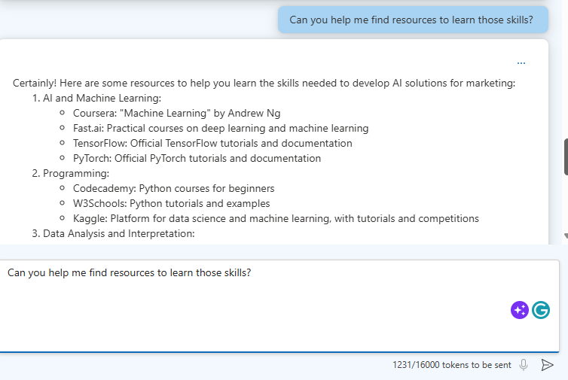

# Experiment Prompt (Explore prompt engineering techniques)

1. In the **Setup** area, select the **default** system message template to set the context for the chat session. The default system message is You are an AI assistant that helps people find information.

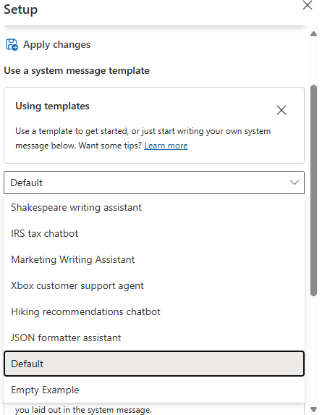

1. In the **Chat session**, submit the following query:

prompt

What kind of article is this?

---

Severe drought likely in California

Millions of California residents are bracing for less water and dry lawns as drought threatens to leave a large swath of the region with a growing water shortage.

In a remarkable indication of drought severity, officials in Southern California have declared a first-of-its-kind action limiting outdoor water use to one day a week for nearly 8 million residents.

Much remains to be determined about how daily life will change as people adjust to a drier normal. But officials are warning the situation is dire and could lead to even more severe limits later in the year.

The response provides a description of the article. However, suppose you want a more specific format for article categorization.

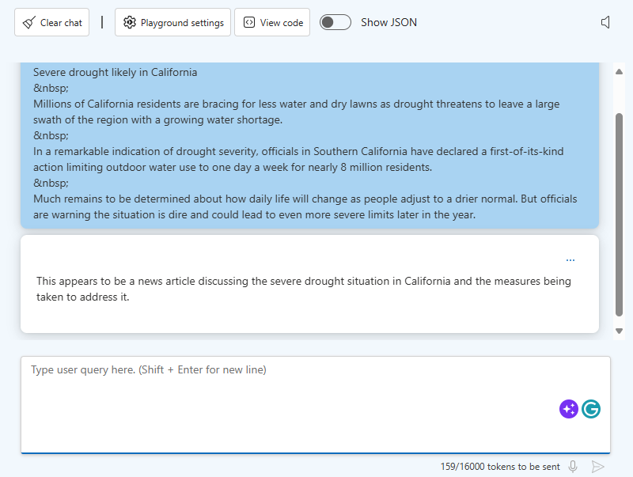

1. In the **Setup** section change the system message to You are a news aggregator that categorizes news articles.
2. Under the new system message, in the **Examples** section, select the **Add** button. Then add the following example.

**User:**

prompt

What kind of article is this?

---

New York Baseballers Wins Big Against Chicago

New York Baseballers mounted a big 5-0 shutout against the Chicago Cyclones last night, solidifying their win with a 3 run homerun late in the bottom of the 7th inning.

Pitcher Mario Rogers threw 96 pitches with only two hits for New York, marking his best performance this year.

The Chicago Cyclones' two hits came in the 2nd and the 5th innings but were unable to get the runner home to score.

**Assistant:**

prompt

Sports

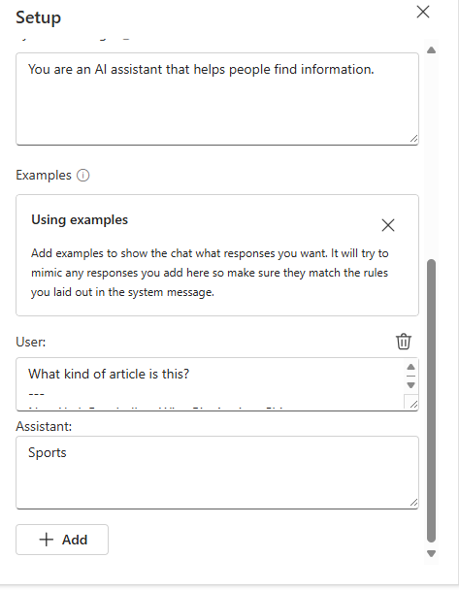

1. Add another example with the following text.

**User:**

prompt

Categorize this article:

---

Joyous moments at the Oscars

The Oscars this past week where quite something!

Though a certain scandal might have stolen the show, this year's Academy Awards were full of moments that filled us with joy and even moved us to tears.

These actors and actresses delivered some truly emotional performances, along with some great laughs, to get us through the winter.

From Robin Kline's history-making win to a full performance by none other than Casey Jensen herself, don't miss tomorrows rerun of all the festivities.

**Assistant:**

prompt

Entertainment

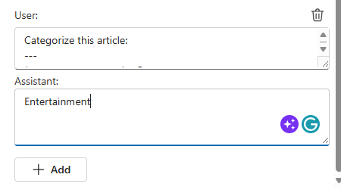

1. Use the **Apply changes** button at the top of the **Setup** section to update the system message.

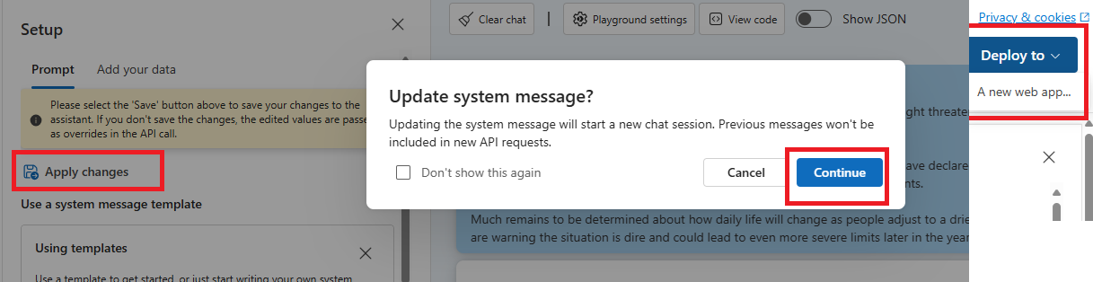

1. In the **Chat session** section, resubmit the following prompt:

prompt

What kind of article is this?

---

Severe drought likely in California

Millions of California residents are bracing for less water and dry lawns as drought threatens to leave a large swath of the region with a growing water shortage.

In a remarkable indication of drought severity, officials in Southern California have declared a first-of-its-kind action limiting outdoor water use to one day a week for nearly 8 million residents.

Much remains to be determined about how daily life will change as people adjust to a drier normal. But officials are warning the situation is dire and could lead to even more severe limits later in the year.

The combination of a more specific system message and some examples of expected queries and responses results in a consistent format for the results.

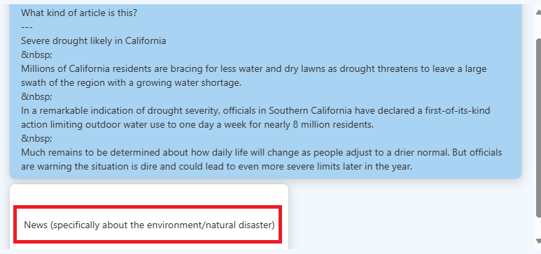

1. In the **Setup** section, change the system message back to the default template, which should be You are an AI assistant that helps people find information. with no examples. Then apply the changes.

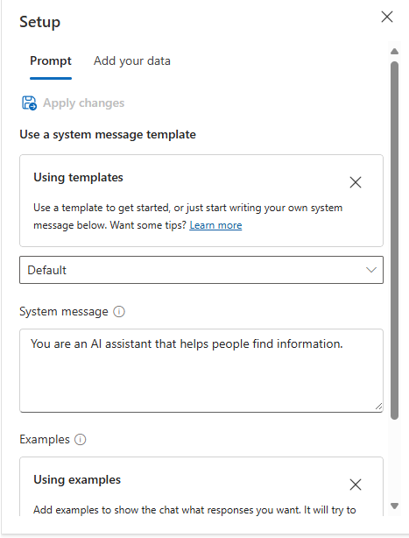

1. In the **Chat session** section, submit the following prompt:

prompt

# 1. Create a list of animals

# 2. Create a list of whimsical names for those animals

# 3. Combine them randomly into a list of 25 animal and name pairs

The model will likely respond with an answer to satisfy the prompt, split into a numbered list. This is an appropriate response, but suppose what you actually wanted was for the model to write a **Python program** that performs the tasks you described?

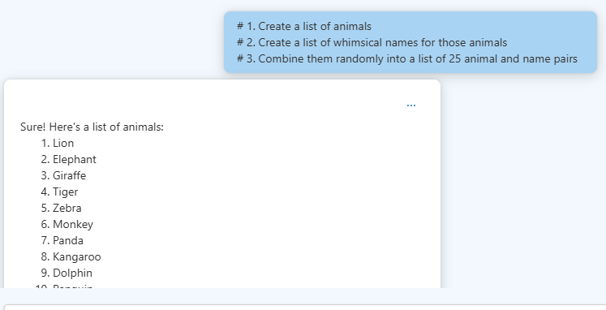

1. Change the system message to You are a coding assistant helping write python code. and apply the changes.

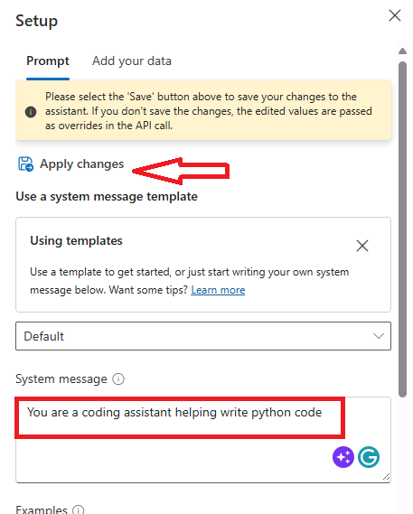

1. Resubmit the following prompt to the model:
2. # 1. Create a list of animals
3. # 2. Create a list of whimsical names for those animals

# 3. Combine them randomly into a list of 25 animal and name pairs

The model should correctly respond with python code doing what the comments requested.

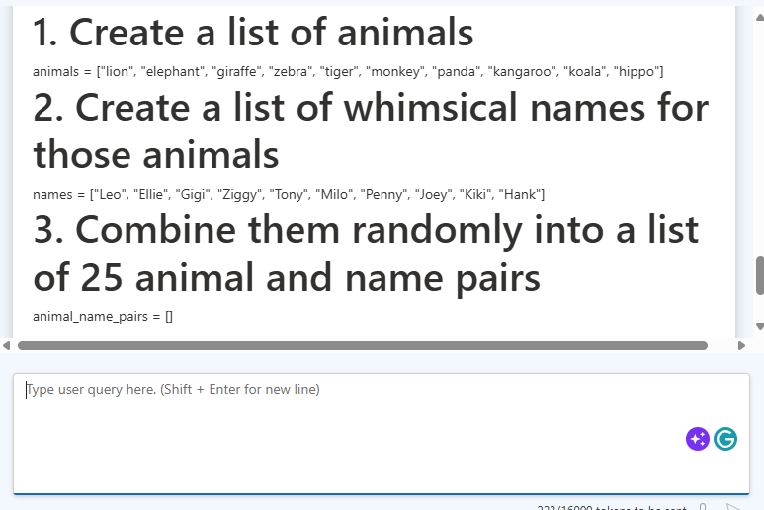

# Prepare to develop an app in Visual Studio Code

Now let's explore the use of prompt engineering in an app that uses the Azure OpenAI service SDK. You'll develop your app using Visual Studio Code. The code files for your app have been provided in a GitHub repo.

**Tip**: If you have already cloned the **mslearn-openai** repo, open it in Visual Studio code. Otherwise, follow these steps to clone it to your development environment.

1. Start Visual Studio Code.
2. Open the palette (SHIFT+CTRL+P) and run a **Git: Clone** command to clone the https://github.com/MicrosoftLearning/mslearn-openai repository to a local folder (it doesn't matter which folder).
3. When the repository has been cloned, open the folder in Visual Studio Code.

**Note**: If Visual Studio Code shows you a pop-up message to prompt you to trust the code you are opening, click on **Yes, I trust the authors** option in the pop-up.

1. Wait while additional files are installed to support the C# code projects in the repo.

**Note**: If you are prompted to add required assets to build and debug, select **Not Now**.

# Configure your application

Applications for both C# and Python have been provided, and both apps feature the same functionality. First, you'll complete some key parts of the application to enable using your Azure OpenAI resource with asynchronous API calls.

1. In Visual Studio Code, in the **Explorer** pane, browse to the **Labfiles/03-prompt-engineering** folder and expand the **CSharp** or **Python** folder depending on your language preference. Each folder contains the language-specific files for an app into which you're you're going to integrate Azure OpenAI functionality.
2. Right-click the **CSharp** or **Python** folder containing your code files and open an integrated terminal. Then install the Azure OpenAI SDK package by running the appropriate command for your language preference:

**C#**:

dotnet add package Azure.AI.OpenAI --version 1.0.0-beta.14

1. In the **Explorer** pane, in the **CSharp** or **Python** folder, open the configuration file for your preferred language
   * **C#**: appsettings.json
2. Update the configuration values to include:
   * The **endpoint** and a **key** from the Azure OpenAI resource you created (available on the **Keys and Endpoint** page for your Azure OpenAI resource in the Azure portal)
   * The **deployment name** you specified for your model deployment (available in the **Deployments** page in Azure OpenAI Studio).
3. Save the configuration file.

# Add code to use the Azure OpenAI service

Now you're ready to use the Azure OpenAI SDK to consume your deployed model.

1. In the **Explorer** pane, in the **CSharp** or **Python** folder, open the code file for your preferred language, and replace the comment **Add Azure OpenAI package** with code to add the Azure OpenAI SDK library:

**C#**: Program.cs

csharp

// Add Azure OpenAI package

using Azure.AI.OpenAI;

1. In the code file, find the comment **Configure the Azure OpenAI client**, and add code to configure the Azure OpenAI client:

**C#**: Program.cs

csharp

// Configure the Azure OpenAI client

OpenAIClient client = new OpenAIClient(new Uri(oaiEndpoint), new AzureKeyCredential(oaiKey));

1. In the function that calls the Azure OpenAI model, under the comment **Format and send the request to the model**, add the code to format and send the request to the model.

**C#**: Program.cs

csharp

// Format and send the request to the model

var chatCompletionsOptions = new ChatCompletionsOptions()

{

Messages =

{

new ChatRequestSystemMessage(systemMessage),

new ChatRequestUserMessage(userMessage)

},

Temperature = 0.7f,

MaxTokens = 800,

DeploymentName = oaiDeploymentName

};

// Get response from Azure OpenAI

Response<ChatCompletions> response = await client.GetChatCompletionsAsync(chatCompletionsOptions);

1. Save the changes to the code file.

# Run your application

Now that your app has been configured, run it to send your request to your model and observe the response. You'll notice the only difference between the different options is the content of the prompt, all other parameters (such as token count and temperature) remain the same for each request.

1. In the folder of your preferred language, open system.txt in Visual Studio Code. For each of the interations, you'll enter the **System message** in this file and save it. Each iteration will pause first for you to change the system message.
2. In the interactive terminal pane, ensure the folder context is the folder for your preferred language. Then enter the following command to run the application.
   * **C#**: dotnet run

**Tip**: You can use the **Maximize panel size** (**^**) icon in the terminal toolbar to see more of the console text.

1. For the first iteration, enter the following prompts:

**System message**

prompt

You are an AI assistant

**User message:**

prompt

Write an intro for a new wildlife Rescue

1. Observe the output. The AI model will likely produce a good generic introduction to a wildlife rescue.
2. Next, enter the following prompts which specify a format for the response:

**System message**

prompt

You are an AI assistant helping to write emails

**User message:**

prompt

Write a promotional email for a new wildlife rescue, including the following:

- Rescue name is Contoso

- It specializes in elephants

- Call for donations to be given at our website

1. Observe the output. This time, you'll likely see the format of an email with the specific animals included, as well as the call for donations.
2. Next, enter the following prompts that additionally specify the content:

**System message**

prompt

You are an AI assistant helping to write emails

**User message:**

prompt

Write a promotional email for a new wildlife rescue, including the following:

- Rescue name is Contoso

- It specializes in elephants, as well as zebras and giraffes

- Call for donations to be given at our website

\n Include a list of the current animals we have at our rescue after the signature, in the form of a table. These animals include elephants, zebras, gorillas, lizards, and jackrabbits.

1. Observe the output, and see how the email has changed based on your clear instructions.
2. Next, enter the following prompts where we add details about tone to the system message:

**System message**

prompt

You are an AI assistant that helps write promotional emails to generate interest in a new business. Your tone is light, chit-chat oriented and you always include at least two jokes.

**User message:**

prompt

Write a promotional email for a new wildlife rescue, including the following:

- Rescue name is Contoso

- It specializes in elephants, as well as zebras and giraffes

- Call for donations to be given at our website

\n Include a list of the current animals we have at our rescue after the signature, in the form of a table. These animals include elephants, zebras, gorillas, lizards, and jackrabbits.

1. Observe the output. This time you'll likely see the email in a similar format, but with a much more informal tone. You'll likely even see jokes included!
2. For the final iteration, we're deviating from email generation and exploring grounding context. Here you provide a simple system message, and change the app to provide the grounding context as the beginning of the user prompt. The app will then append the user input, and extract information from the grounding context to answer our user prompt.
3. Open the file grounding.txt and briefly read the grounding context you'll be inserting.
4. In your app immediately after the comment **Format and send the request to the model** and before any existing code, add the following code snippet to read text in from grounding.txt to augment the user prompt with the grounding context.

**C#**: Program.cs

csharp

// Format and send the request to the model

Console.WriteLine("\nAdding grounding context from grounding.txt");

string groundingText = System.IO.File.ReadAllText("grounding.txt");

userMessage = groundingText + userMessage;

1. Save the file and rerun your app.
2. Enter the following prompts (with the **system message** still being entered and saved in system.txt).

**System message**

prompt

You're an AI assistant who helps people find information. You'll provide answers from the text provided in the prompt, and respond concisely.

**User message:**

prompt

What animal is the favorite of children at Contoso?

**Tip**: If you would like to see the full response from Azure OpenAI, you can set the **printFullResponse** variable to True, and rerun the app.